Respected Sir/Mam,

I am writing to request your kind permission for my friend KEVAL SAVLA, to check my answer sheet on my behalf for the open house.

As I am currently out of station in my hometown Jammu, I will be unable to present in person to review my answer sheets. However, I trust my friend’s competence and integrity and I believe he will provide an accurate evaluation of my performance.

I would be grateful if you could consider my request and provide the necessary permission to facilitate this arrangement. I am available to discuss any concerns or queries you may have regarding this matter.

Yours Sincerely

Akhil Sharma, UID-2020400051, TE 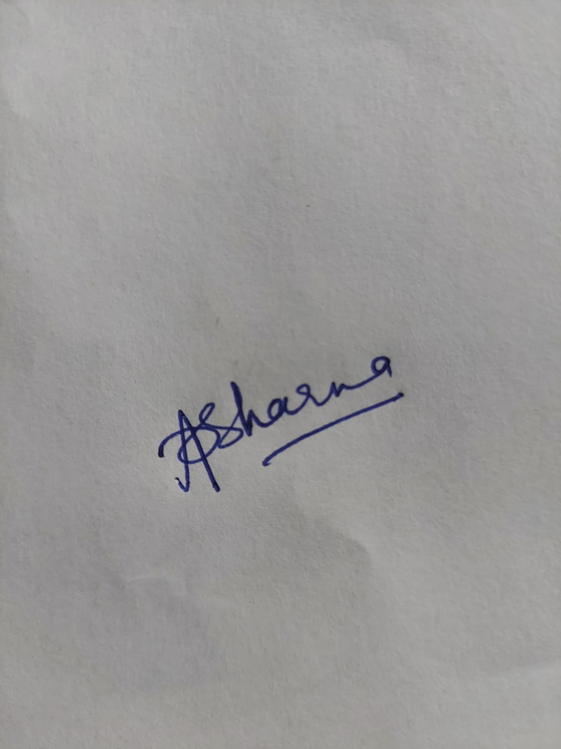IT